ПРИЛОЖЕНИЕ А
Работа с графикой. Анимация

Задание 1. Система бронирования отеля

Листинг программы:

<Window x:Class="Task_1.MainWindow"
xmlns="http://schemas.microsoft.com/winfx/2006/xaml/presentation"
xmlns:x="http://schemas.microsoft.com/winfx/2006/xaml"
xmlns:local="clr-namespace:Task_1"
Title="Система бронирования отеля"
Height="650" Width="1000"
WindowStartupLocation="CenterScreen"
Background="#F8F9FA">
<Window.Resources>
<local:BoolToVisibilityConverter x:Key="BoolToVis"/>
<local:StatusColorConverter x:Key="StatusColor"/>
<SolidColorBrush x:Key="Accent" Color="#4A90E2"/>
<SolidColorBrush x:Key="AccentDark" Color="#357ABD"/>
<SolidColorBrush x:Key="Surface" Color="#FFFFFF"/>
<SolidColorBrush x:Key="Border" Color="#E9ECEF"/>
<SolidColorBrush x:Key="TextMain" Color="#212529"/>
<SolidColorBrush x:Key="TextLight" Color="#6C757D"/>
<SolidColorBrush x:Key="BgHover" Color="#F1F3F5"/>
<Style TargetType="Window">
<Setter Property="FontFamily" Value="Segoe UI, Tahoma, Geneva, Verdana, sans-serif"/>
<Setter Property="Foreground" Value="{StaticResource TextMain}"/>
</Style>

<Style TargetType="TextBox">
<Setter Property="Padding" Value="12,10"/>
<Setter Property="BorderThickness" Value="1"/>
<Setter Property="BorderBrush" Value="{StaticResource Border}"/>
<Setter Property="Background" Value="{StaticResource Surface}"/>
<Setter Property="Template">
<Setter.Value>
<ControlTemplate TargetType="TextBox">

<Border Background="{TemplateBinding Background}"
BorderBrush="{TemplateBinding BorderBrush}"
BorderThickness="{TemplateBinding BorderThickness}"
CornerRadius="8">
<ScrollViewer Margin="{TemplateBinding Padding}" x:Name="PART_ContentHost"/>
</Border>
<ControlTemplate.Triggers>
<Trigger Property="IsFocused" Value="True">
<Setter Property="BorderBrush" Value="{StaticResource Accent}"/>
</Trigger>
</ControlTemplate.Triggers>
</ControlTemplate>
</Setter.Value>
</Setter>
</Style>

<Style TargetType="DatePicker">
<Setter Property="Padding" Value="4"/>
<Setter Property="BorderThickness" Value="0"/>
<Setter Property="Background" Value="{StaticResource Surface}"/>
<Setter Property="Template">

Анализ результатов:
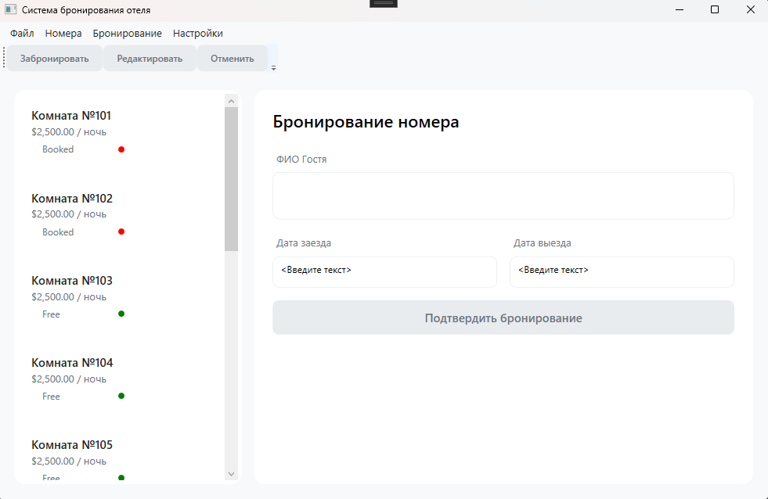
Рисунок 1.1 – Результат работы программы

